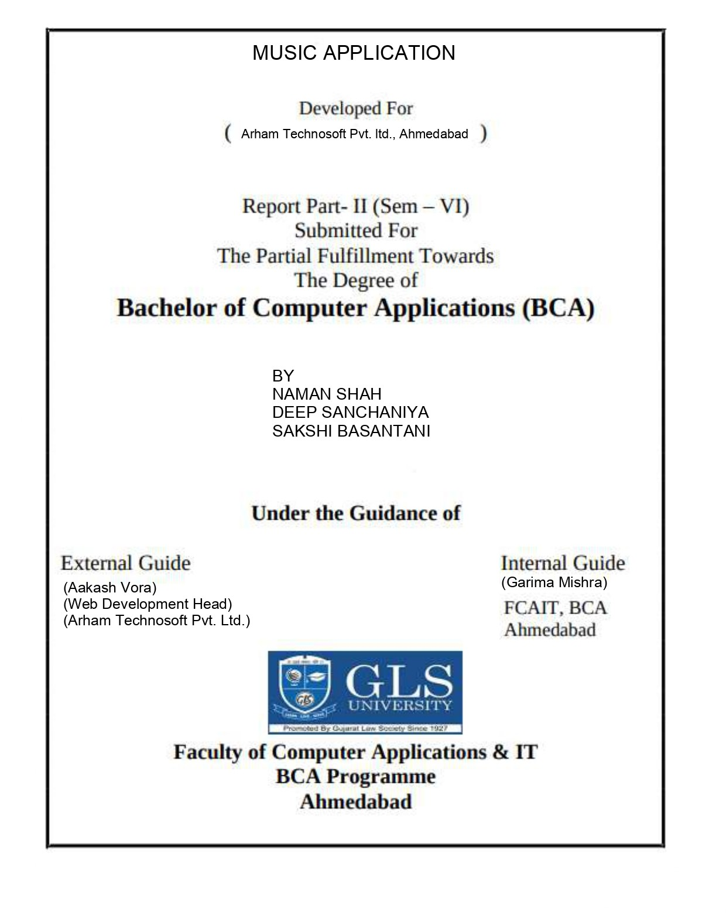

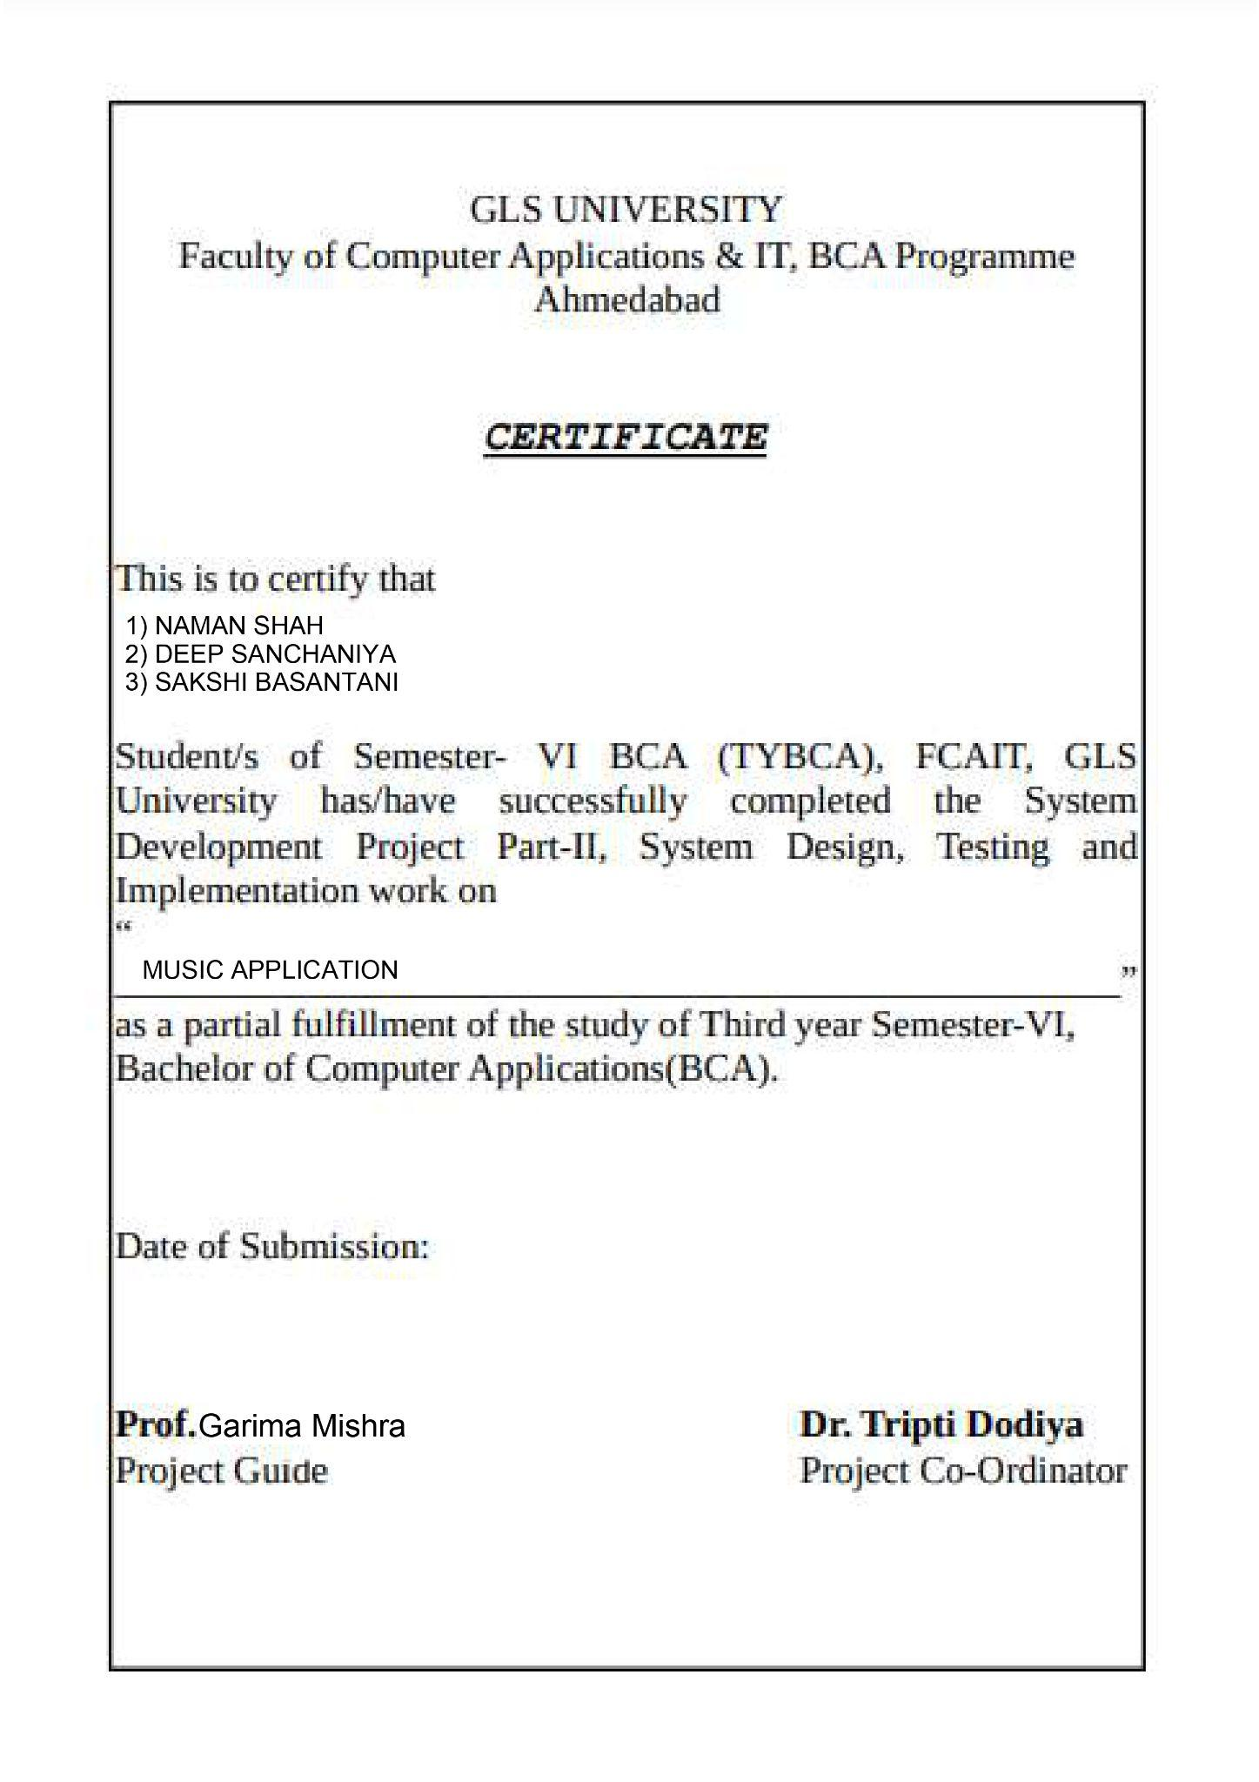

ACKNOWLEDGEMENT

We are thankful to all those people who have directly or indirectly contributed to create this project & helped us a lot to make it a great success. We are thankful for this experience that will change our career.

We grabbed this opportunity to introduce the project of Music Application as a part of our 6th Semester BCA.

First of all we would like to express our sincere gratitude to Prof. Garima mam for giving us a great opportunity to develop a Music Application. We would also like to thank her for giving guidance & constant inspiration with the valuable

suggestions during project work.

We are extremely thankful to each and every team member of Arham Technosoft.PVT.LTD. As they share their valuable time with us for our project and solve our problem.

We are grateful to all the members of Music App for their kind support and suggestion during the development stage.

INDEX

| SERIAL NUMBER | CONTENT | PAGE NUMBER |
| --- | --- | --- |
| 1 | PROJECT PROFILE | 5 |
| 2 | SCREEN LAYOUTS AND REPORTS | 6 |
| 3 | CONCLUSION | 12 |

PROJECT PROFILE

TOOLS AND TECHNOLOGY USED

SOFTWARE USED :-

| FRONT END | IONIC FRAMEWORK,ANGULAR,  JAVASCRIPT, HTML, CSS |
| --- | --- |
| BACK END | FIREBASE |

EXISTING SYSTEM

Currently we face problems while listening to music because of advertisements after every song and also advertisement banners on the screen. The experience of enjoying music is disturbed because of the advertisement and to avoid it we need to pay a subscription.

PROPOSED SYSTEM

This project will be a Music Streaming App. Using Ionic Framework for building Hybrid mobile applications . Firebase for making ApplicationProgramming Interface (API) and data storage.

SCREEN LAYOUTS

LOGIN AND REGISTRATION :-

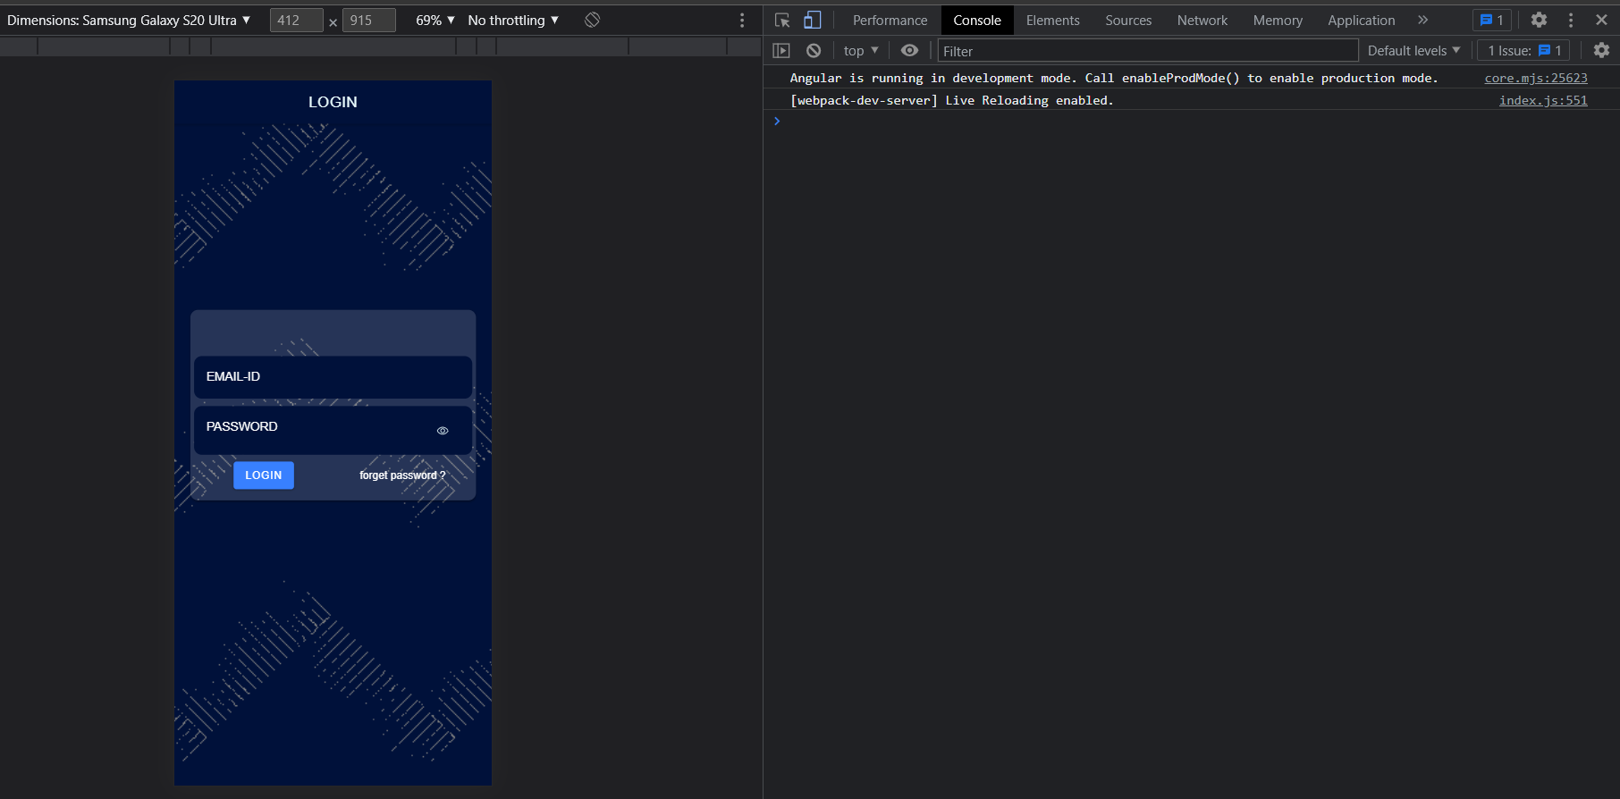

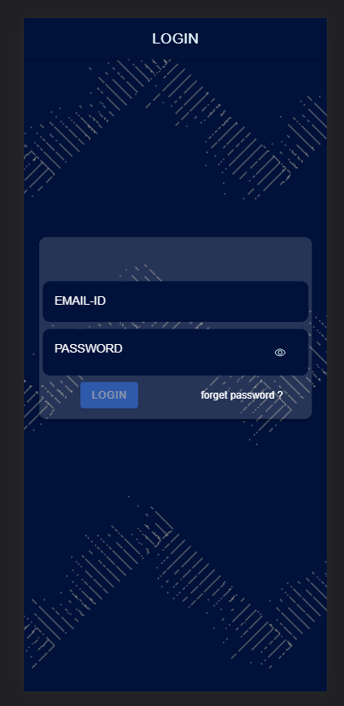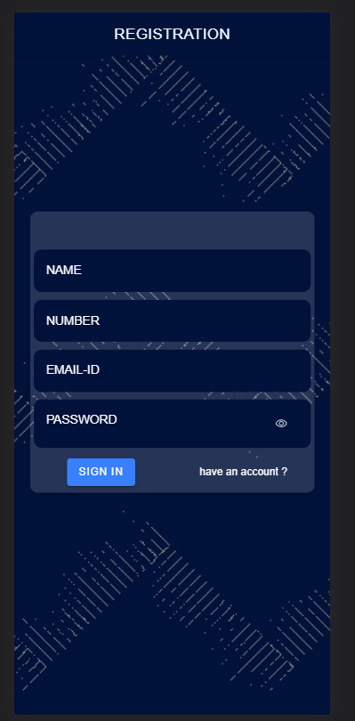

VALIDATIONS FOR LOGIN

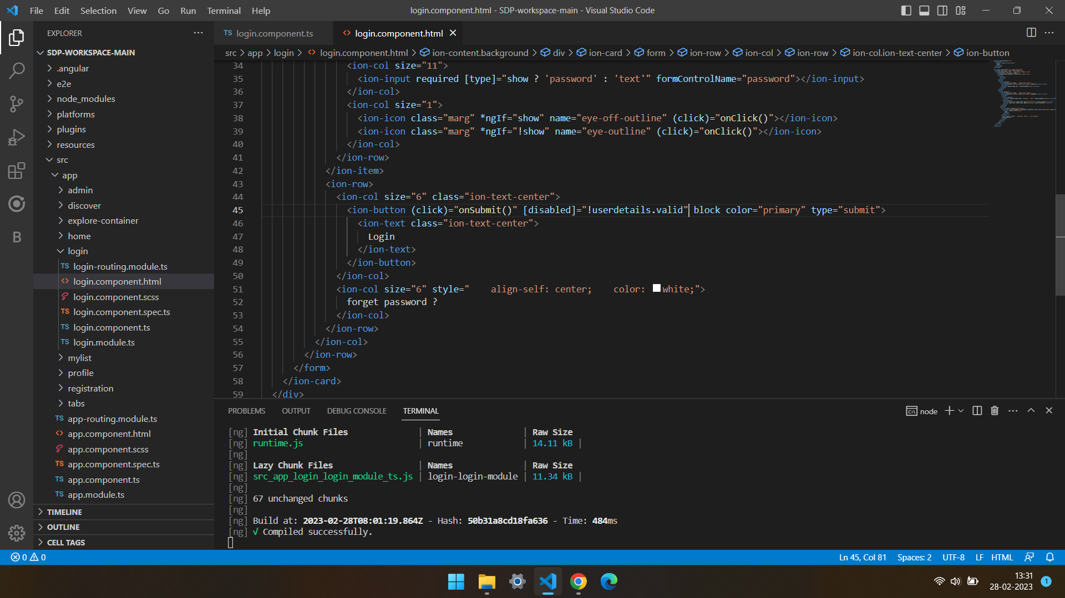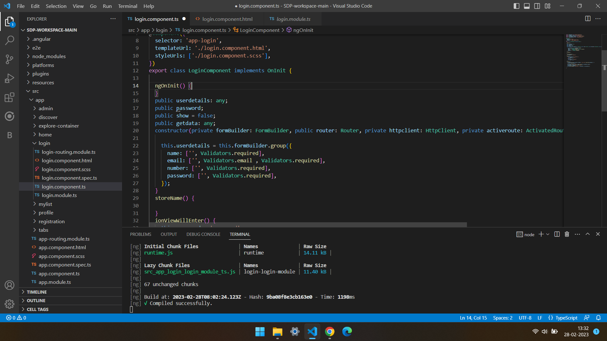

HOME PAGE

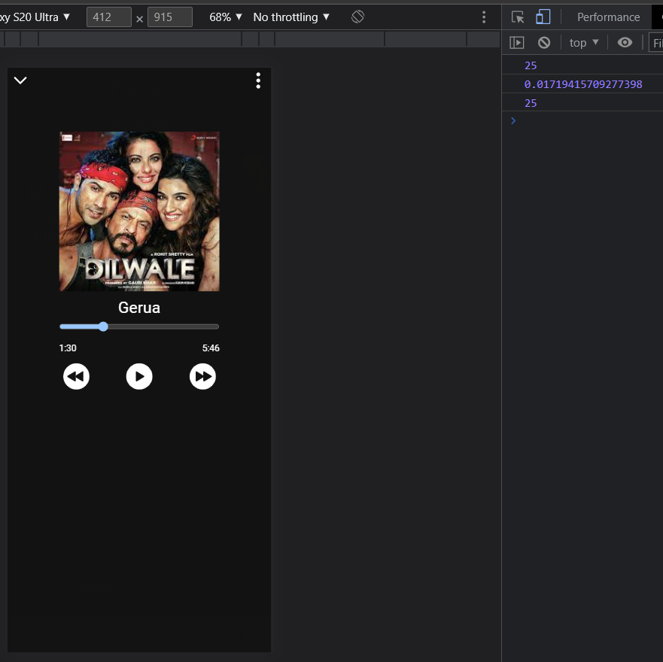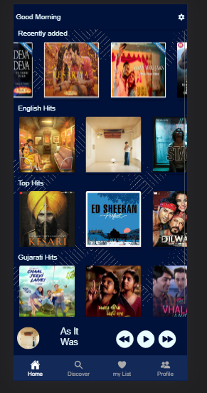

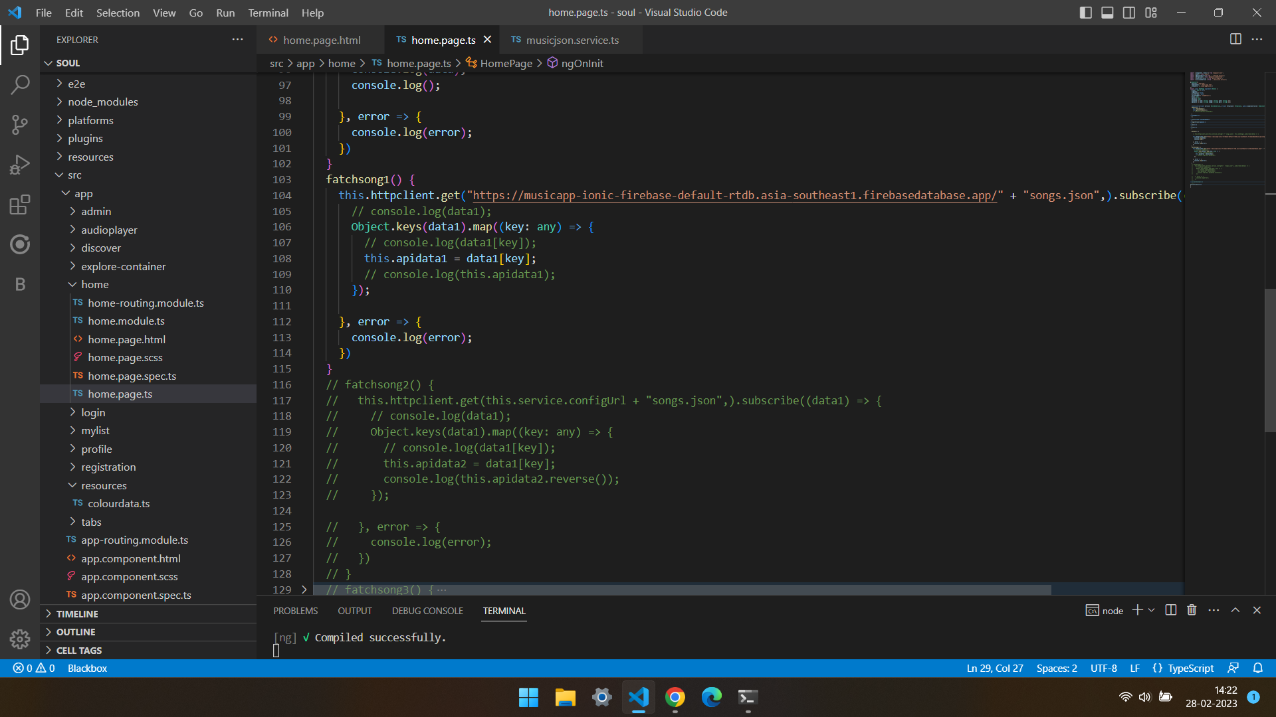

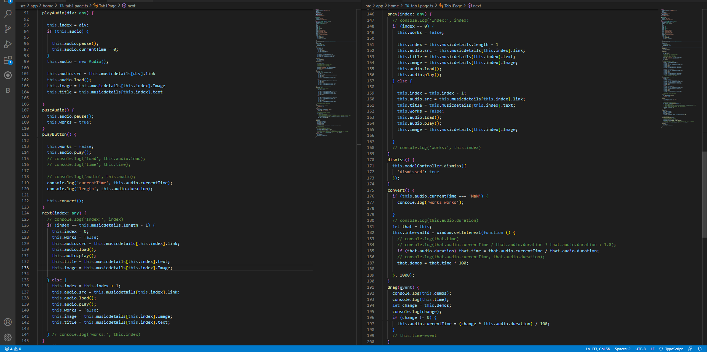

DISCOVER PAGE

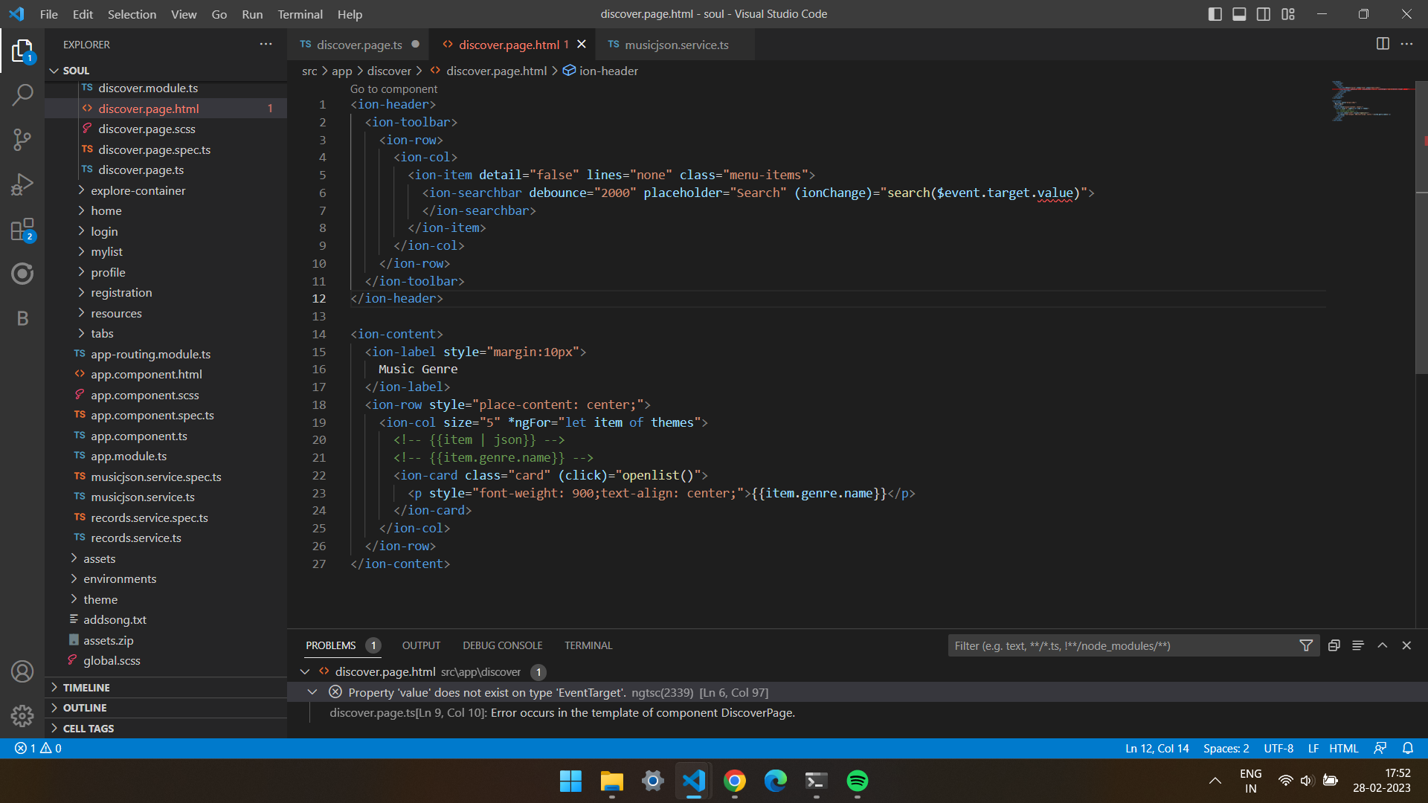

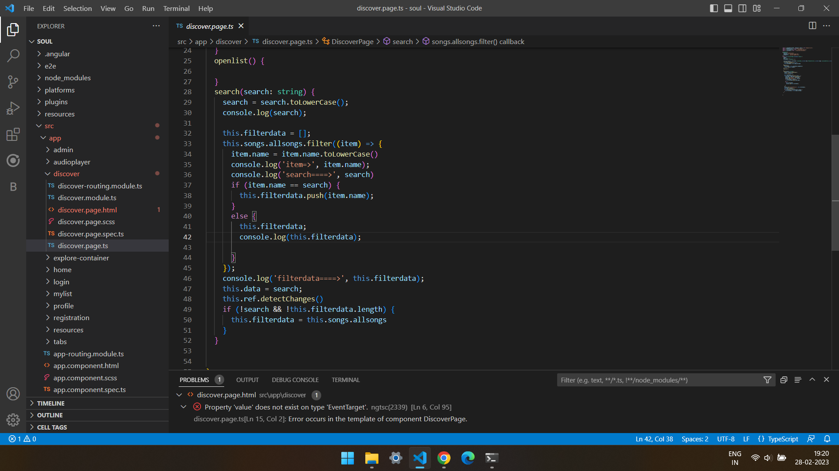

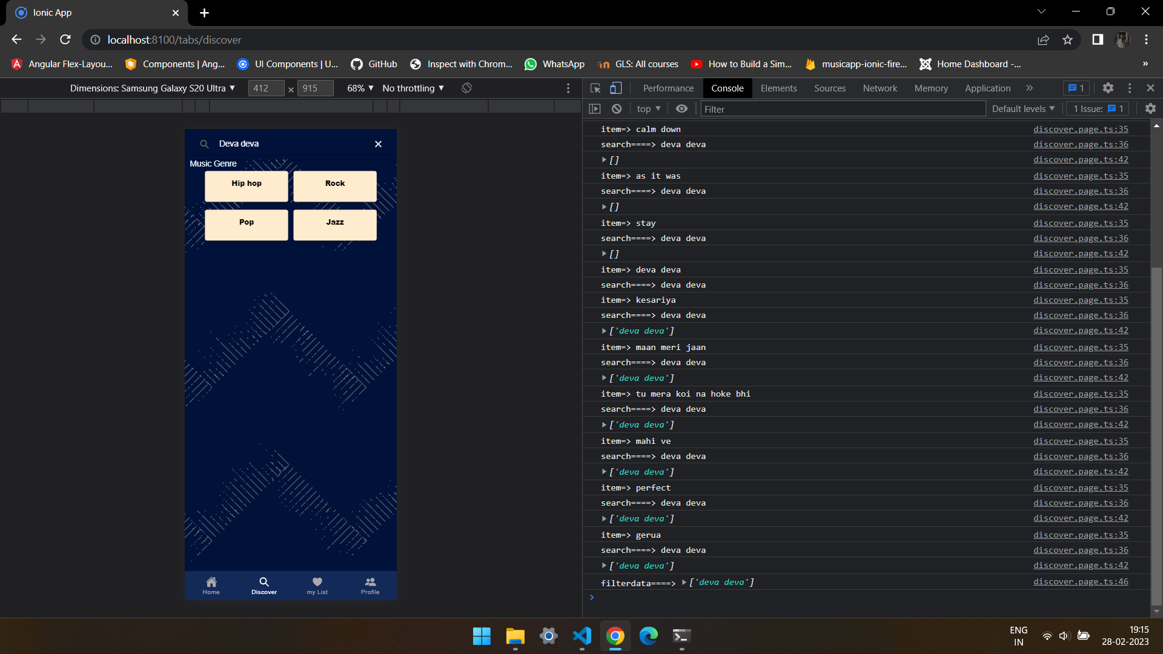

MY LIST PAGE

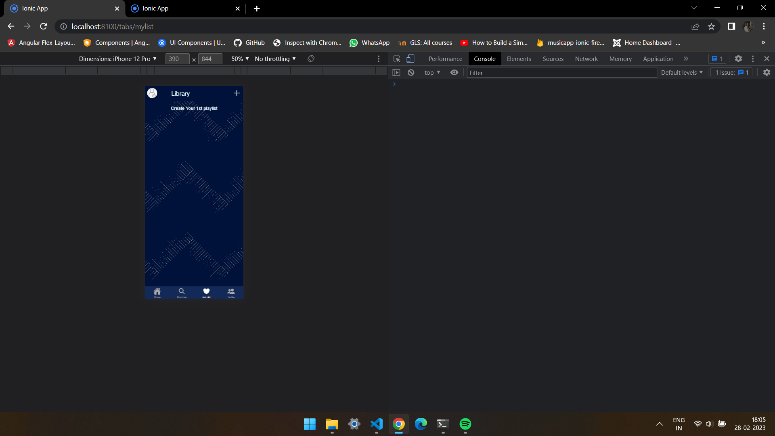

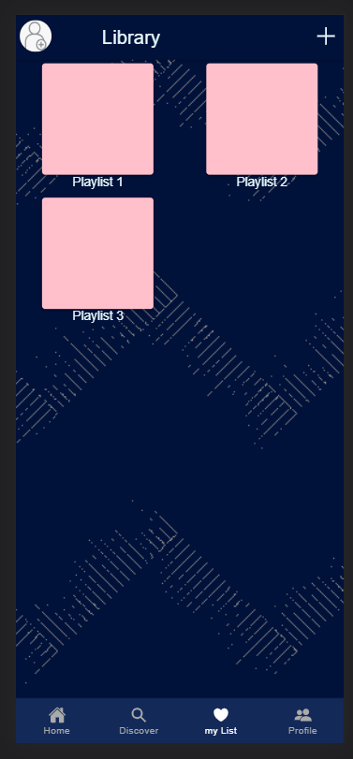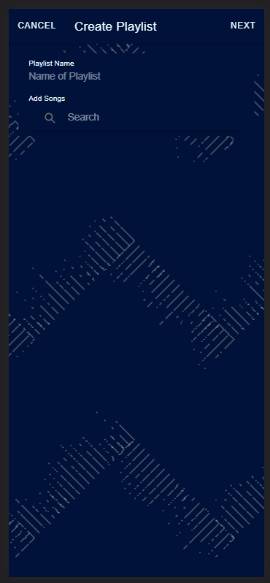

PROFILE PAGE

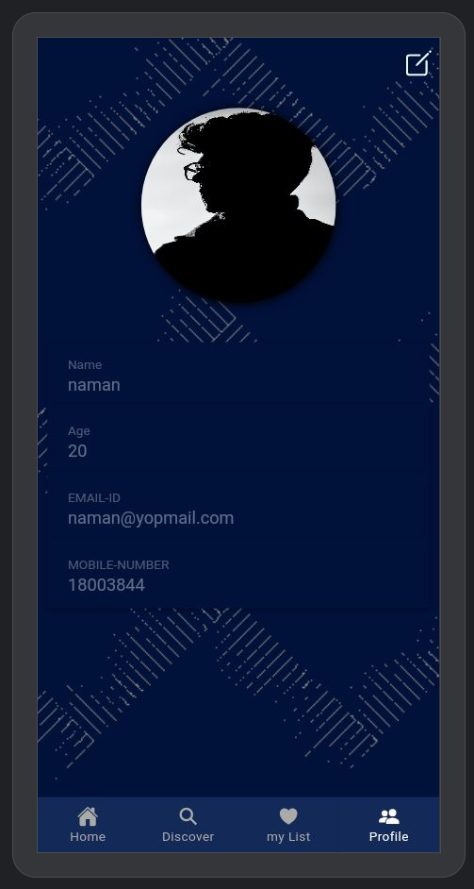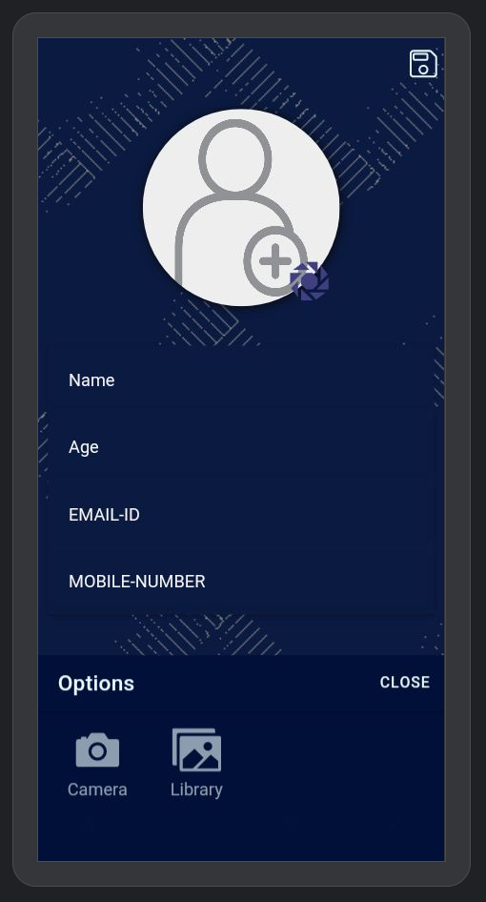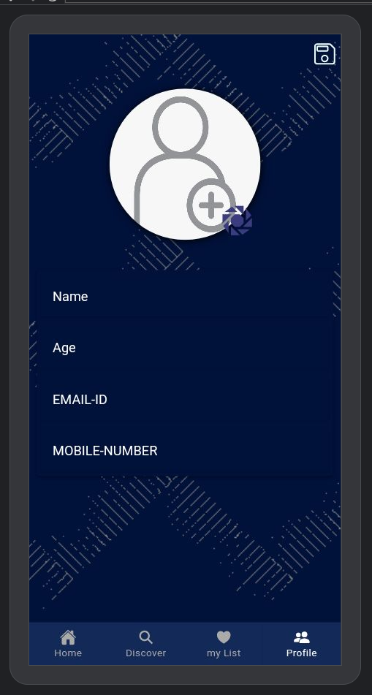

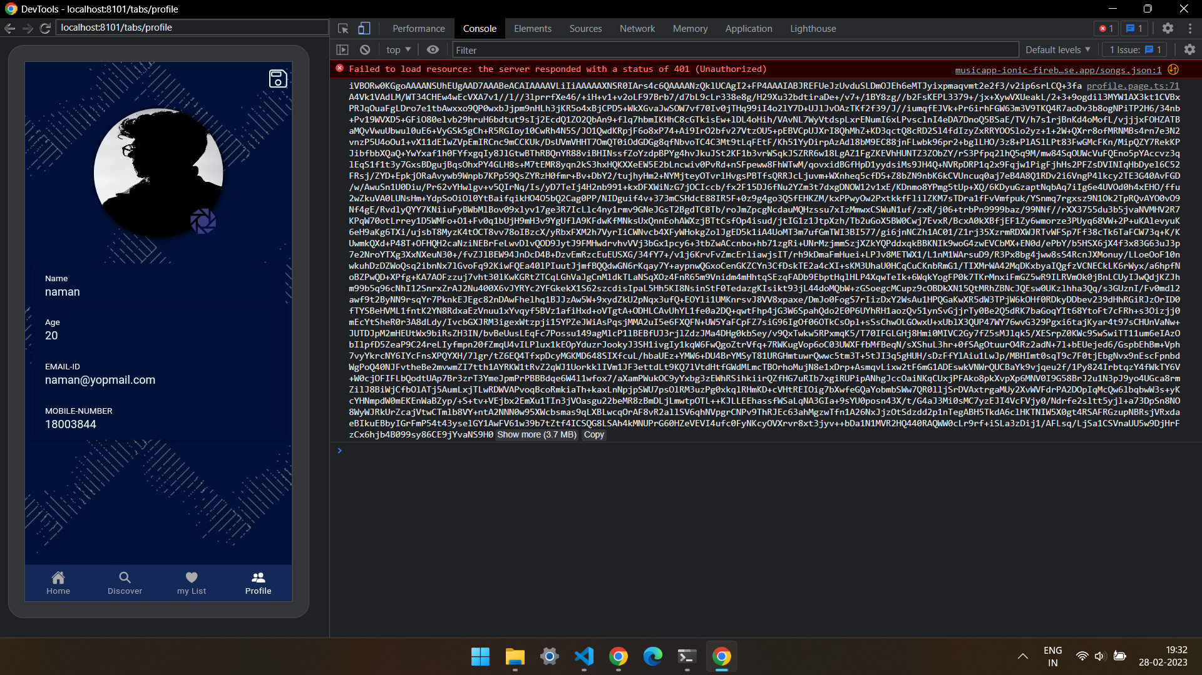

CONCLUSION

Our main aim is to provide user experience with a proper user-interface to interact with our music Application .

Thus users can enjoy their own choice of music anytime and without any advertisement.

Our internal guide Prof. Garima mam helped us a lot in improving the quality of our project.

As well as our external guide Mr. Aakash vora helped us a lot in

giving suggestions for better functioning of our project.